Student’s name | …………………………………………………….…… | Grade | 4
Subject | Computer | Week No. | 10
Lesson Title | Presentation | Unit
Worksheet No. ( 10 )
Question A:

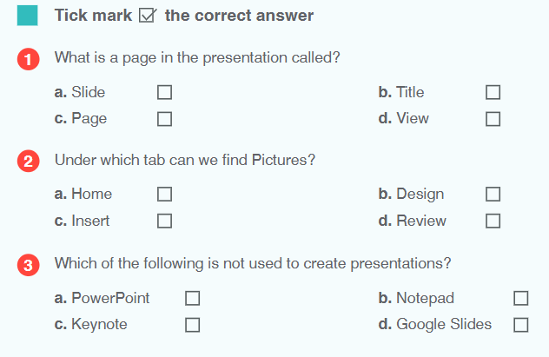
Good Luck

